# Gender Discrimination Lawsuit against Harris Bank:

The claim was made that the bank compensated female employees at a significantly lower rate than male employees with comparable education and experience.

## **In Favor the Law:**

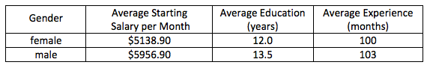

If you investigate the above summary statistics, it’s clearly saying that female employees are getting lower compensate comparison to male employees with comparable education and experience.

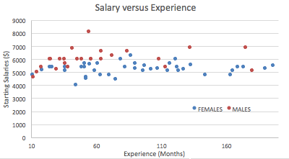

Also look at the above graph, most of the male employees are getting more than $6000 even with less experience. On the other hand, a huge percentage of female employees are getting bellow $6000 even with far more experience than male employees.

So, there is a clear gender discrimination in Harris Bank.

## **Against the Law:**

If you deeper dive above summary statistics, the statistics giving you the average so there may be some outliers those are affecting the average. Also, if you look at the average education then male employees have more education years than female employees. So, it’s clear that Harris bank giving more priority to employees those have more education irrespective of gender.

Now let’s look at the bellow graph:

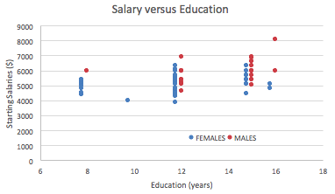

Here as you can see some of the female employees with almost 12 years of education are getting higher salary than some of the male employees or comparable to male employees. There are only two female employees with around 16 years of education those are getting very less. Here is the question why. And there is one male employee who is getting around $8000 with 16 years of education.

On the other hand, if you look into the Salary vs Experience graph you can see the data points are uniformly distributed that means there is a very less chance of getting more compensate with more years of experience.

There is one more question, what is the total number of female and male employees in Harris bank. The datapoints showing that there are more female employees in Harris bank. If there is discrimination, then why there are more female employees in Harris bank.